|  |  |  |  |  |  |
| --- | --- | --- | --- | --- | --- |
| Date | 6-Dec-22 | | | Tester Name | Mohammad Yusuf |
| Environment | Penfax - Test | | | Login used |  |
| Operating System | Windows | Version: | Update: | | |
| Software Used | Select Software | Version: | Update: | | |
| Select Software | Version: | Update: | | |
| Release version |  | | | | |
| Title |  | | | | |
| Test Type | Regression | | | | |
| Test Scenario |  | | | | |
|  |  | | | | |
| Expected Results |  | | | | |
| Pass/Fail | Select | | | JIRA# | N/A |

Describe your steps with screenshots:

Search for the Member. Retired & Married

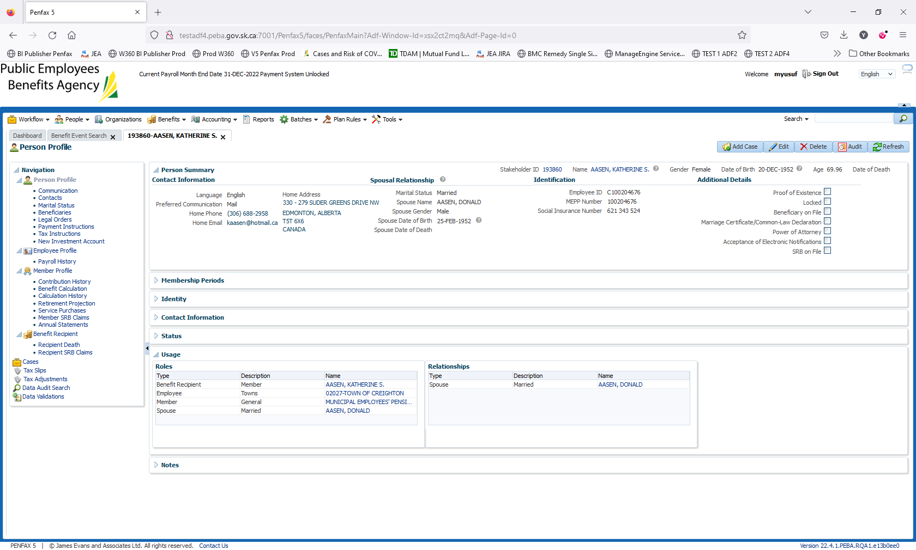

Enter the Date of Death. Save it.

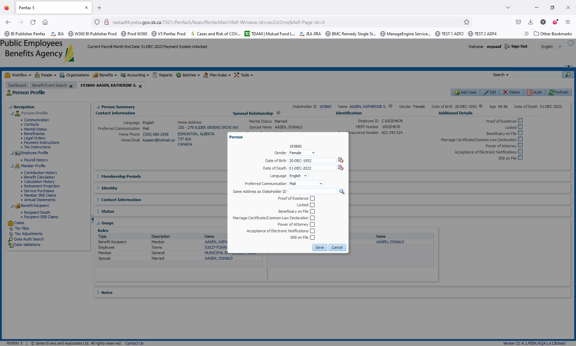

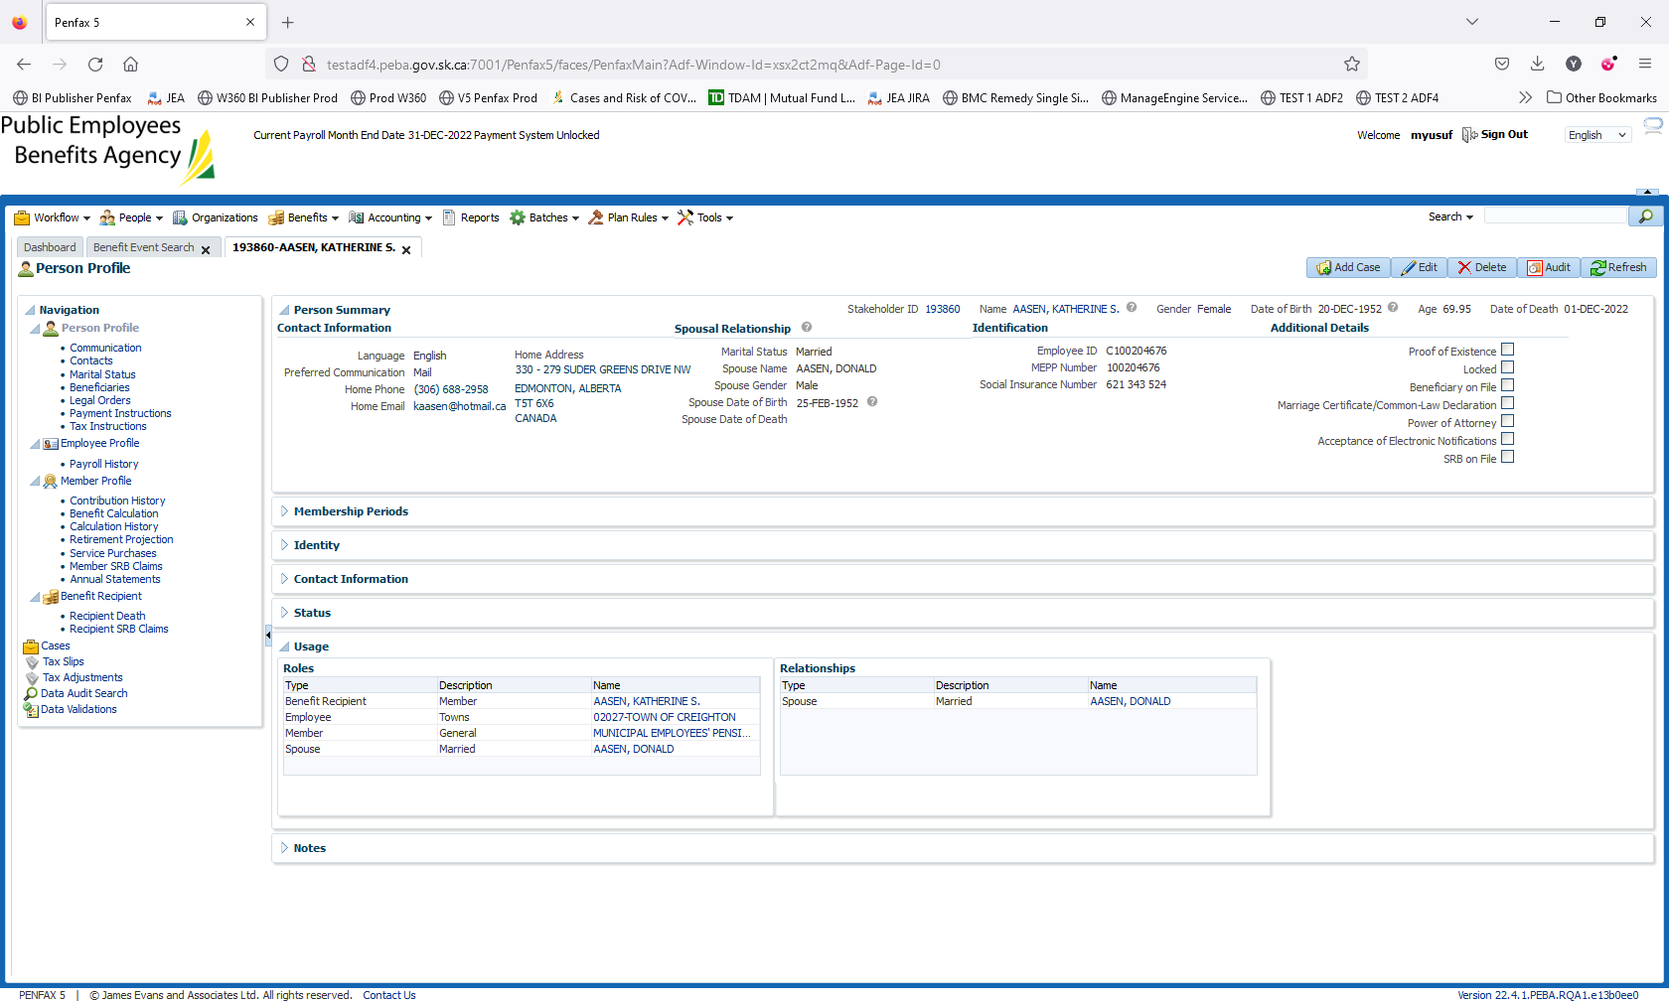

Go to Person Profile -> Beneficiaries

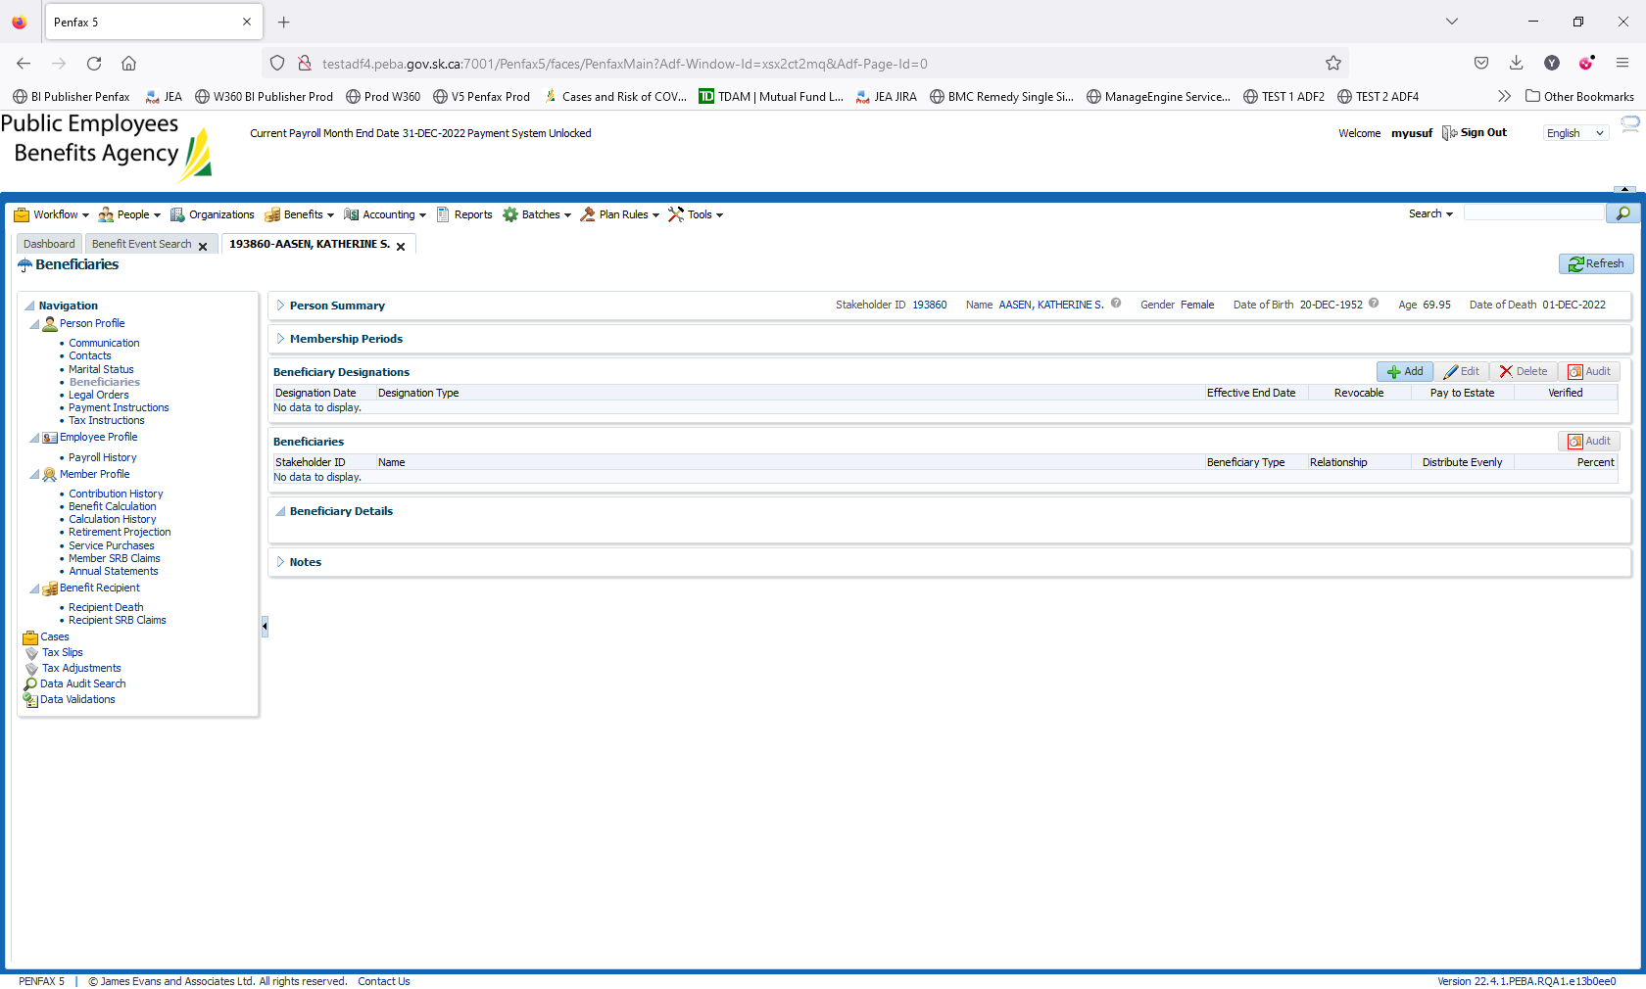

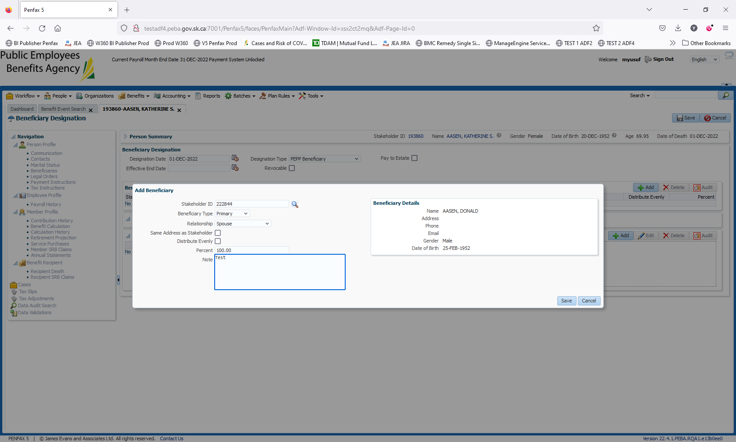

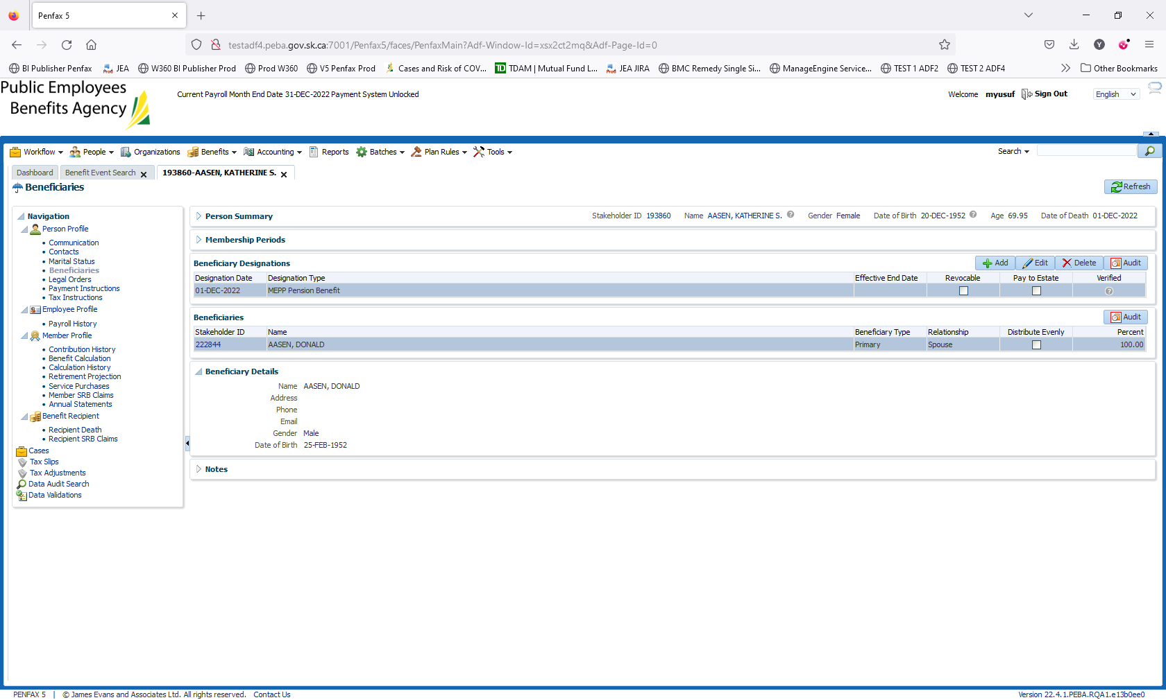

Add the Designation Type: MEPP Pension Benefit

Click on add for Beneficiaries

Add the details as in Screenshot and save it.

Navigate to Benefit Recipient – Recipient Death

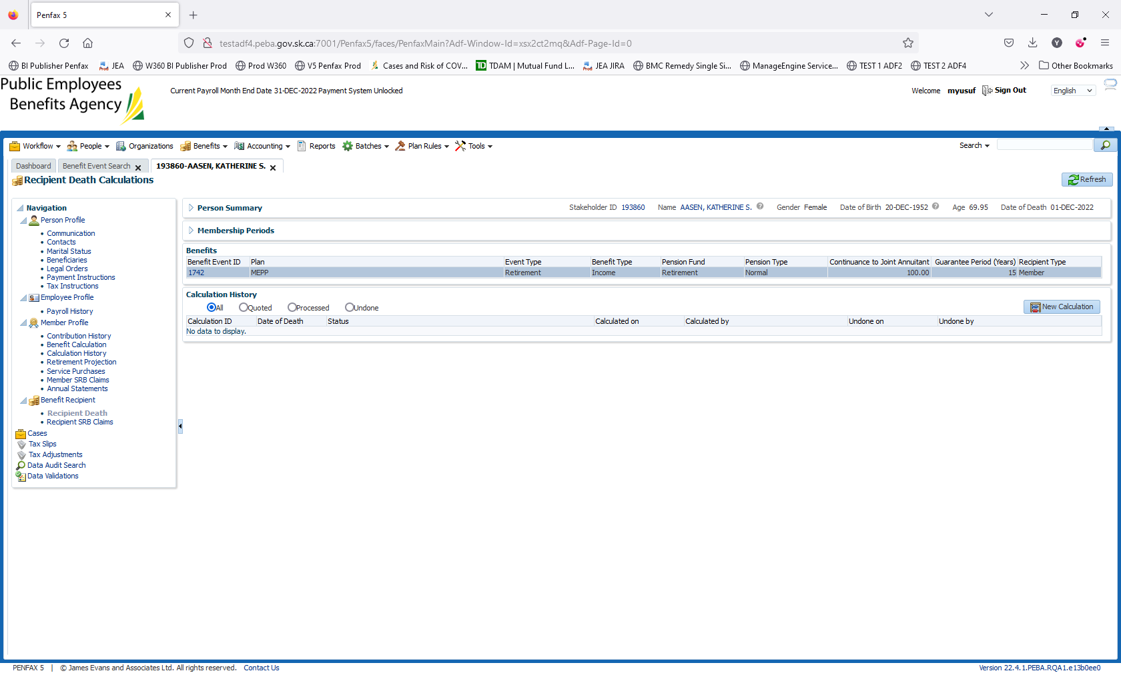

Click on New Calculation

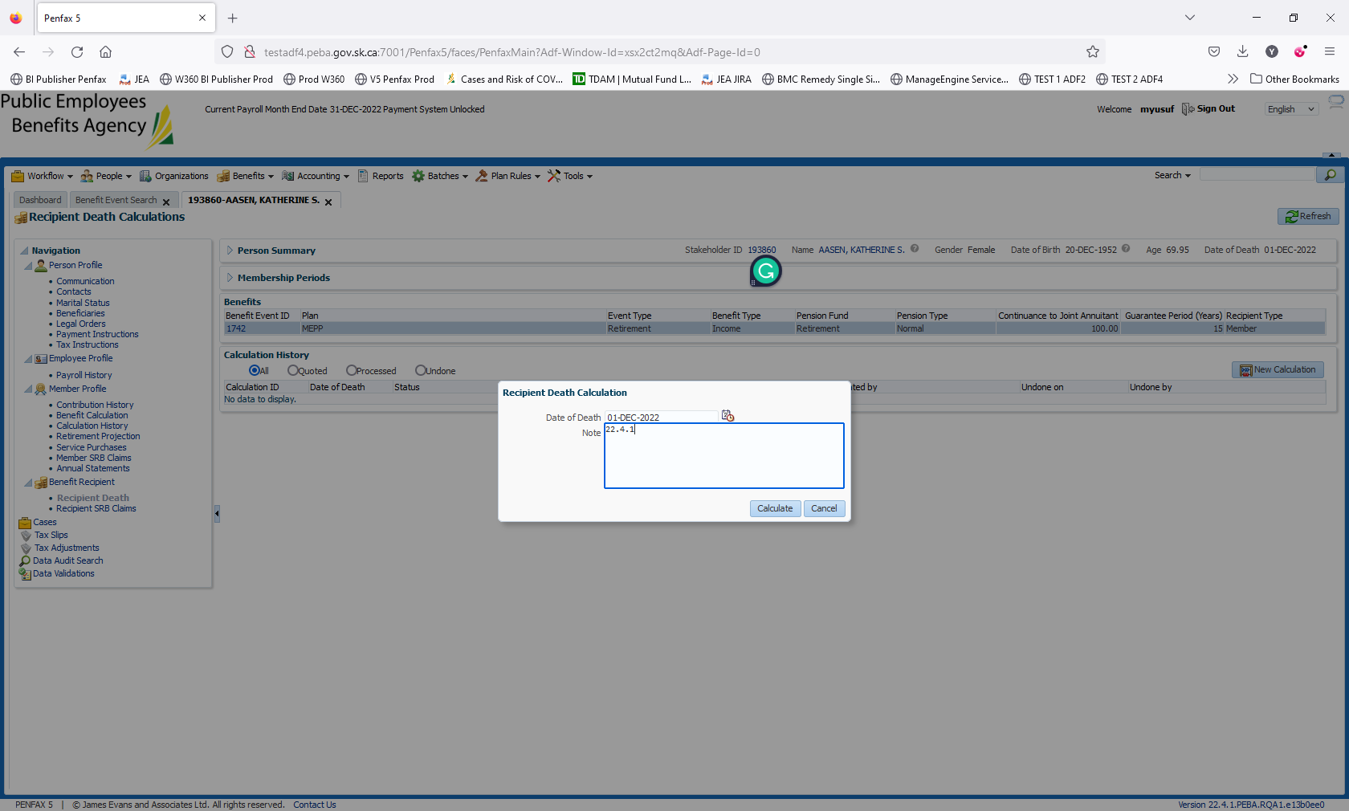

Hit Calculate. Then process it twice

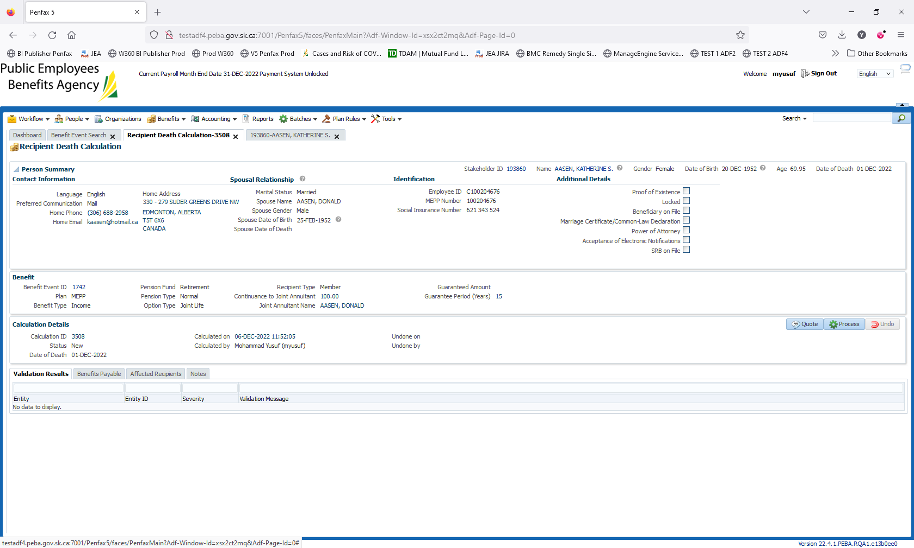

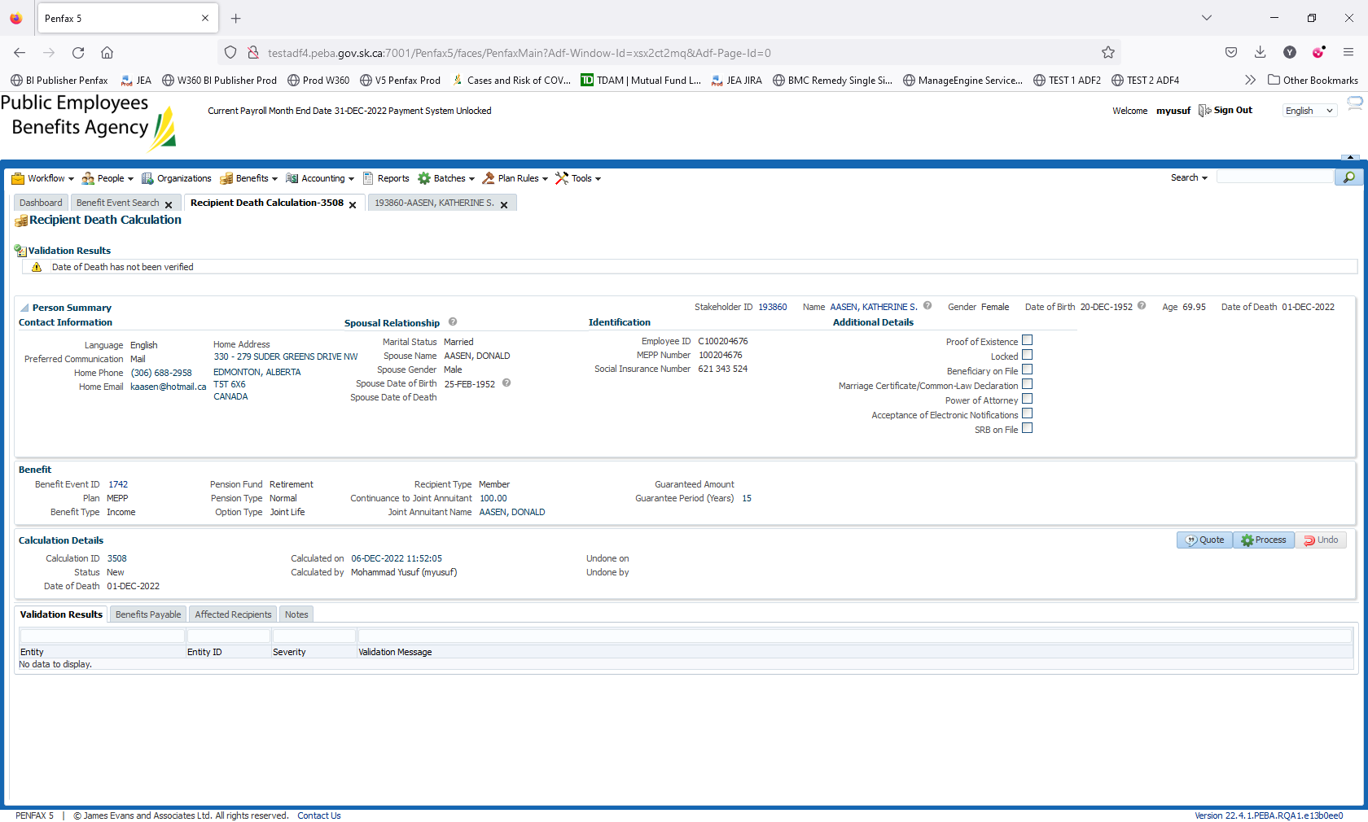

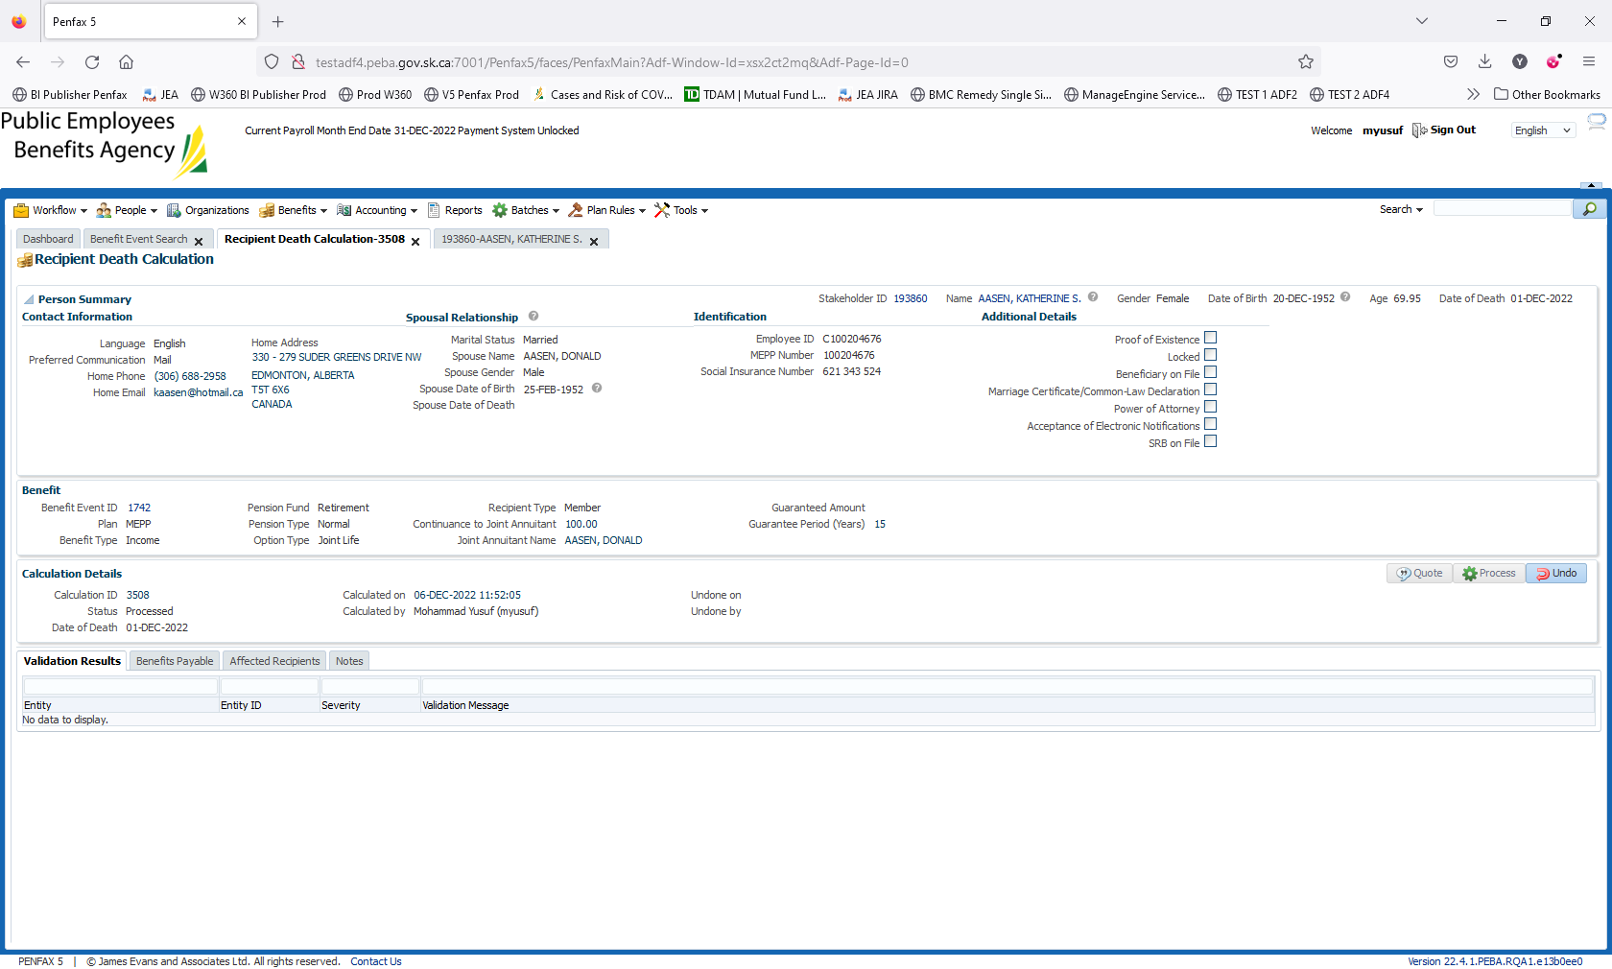

Go to Benefits Payable. Click on Process Recipient

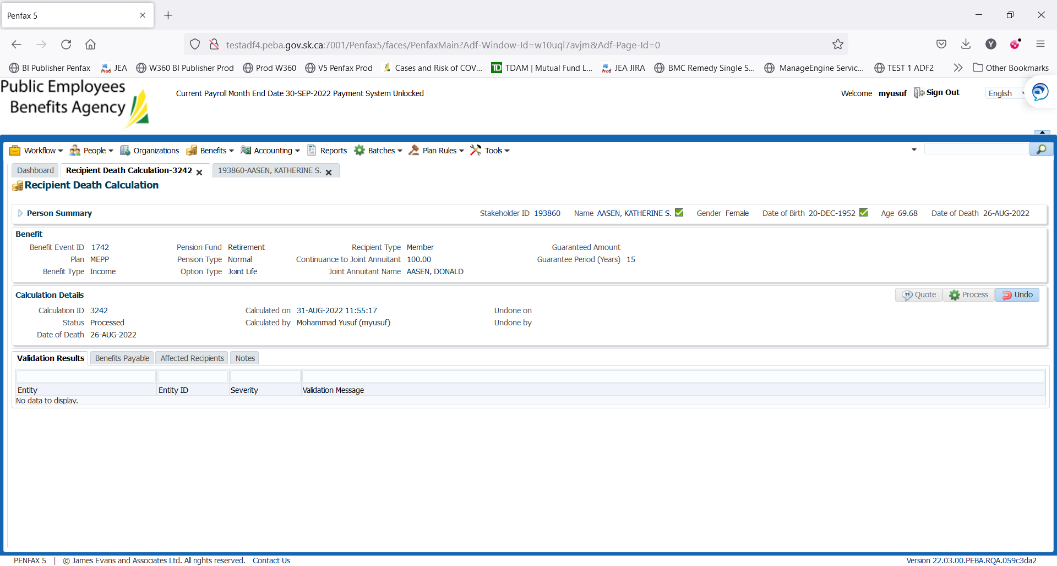

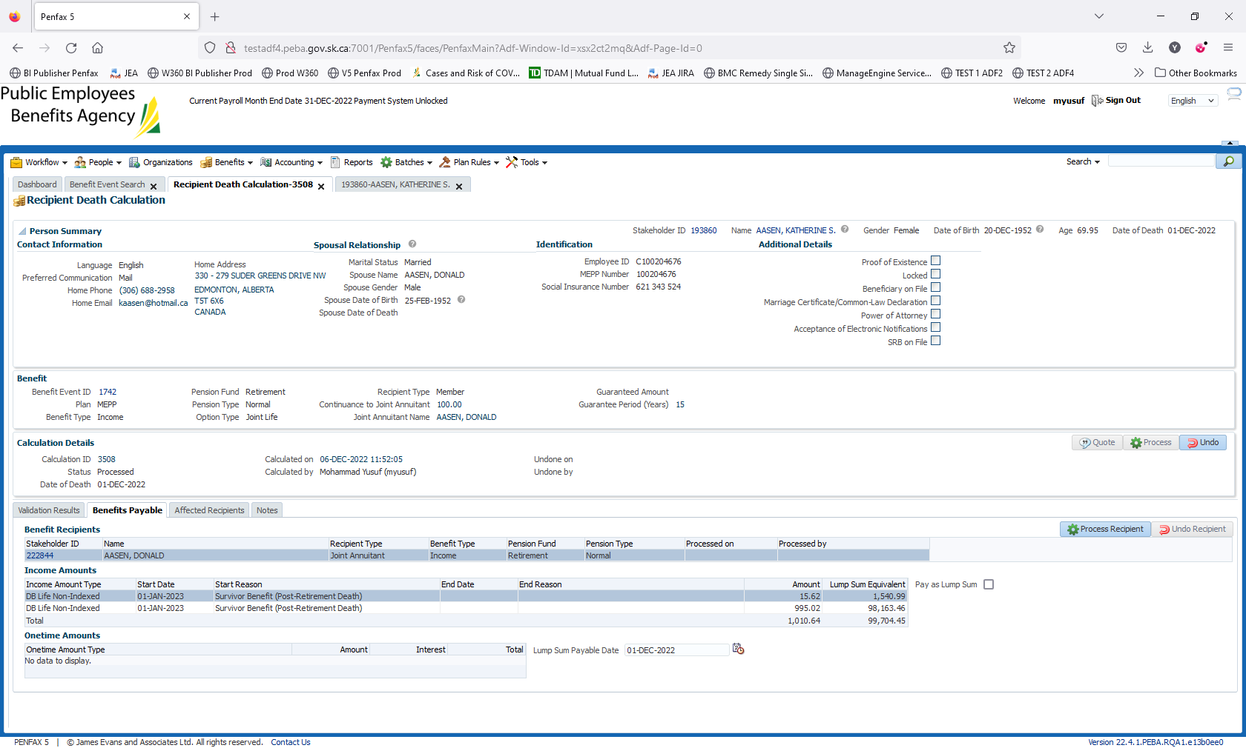

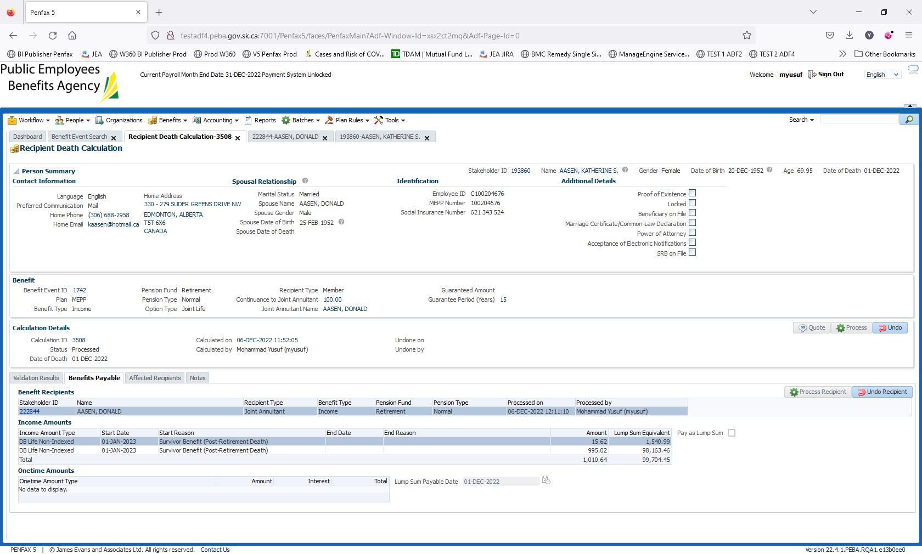

Go to the Beneficiary 222844. Authorize the Payments

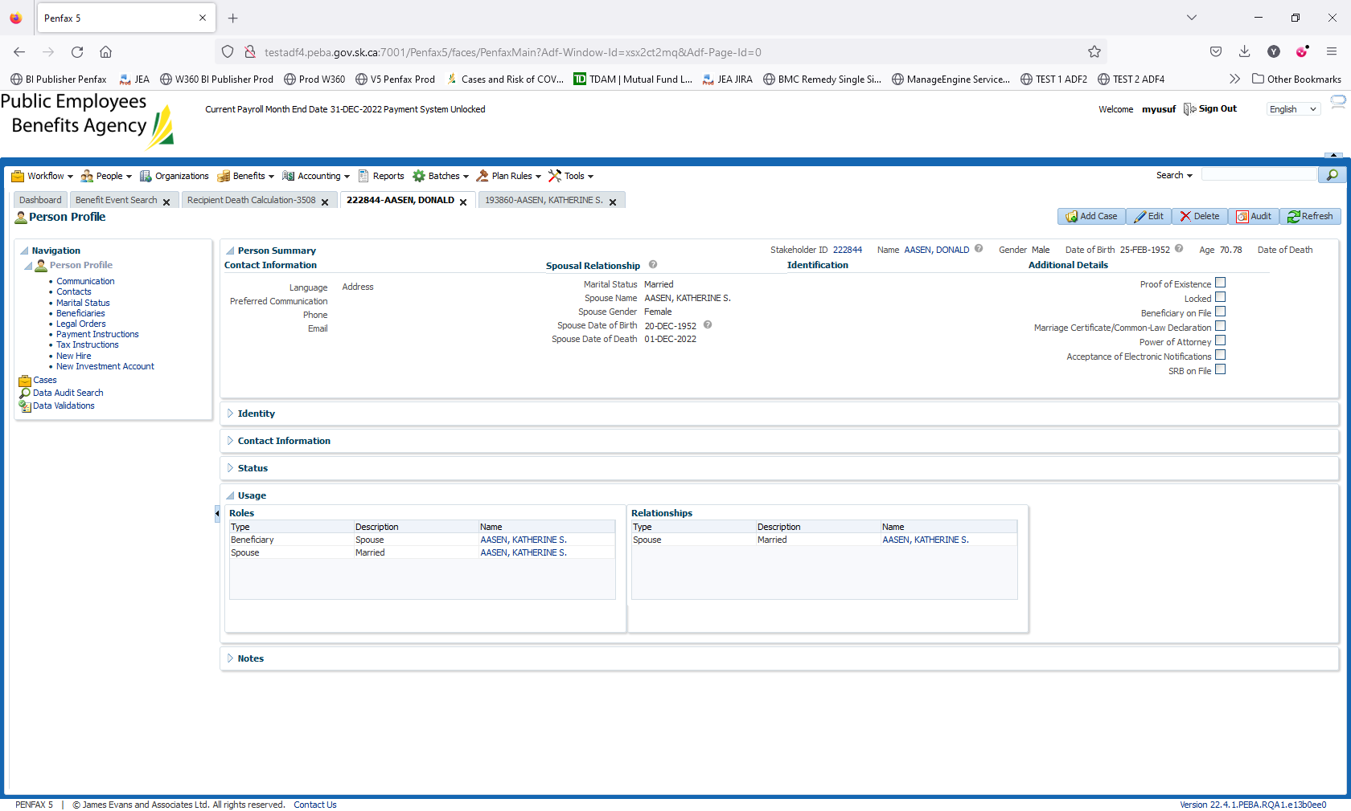

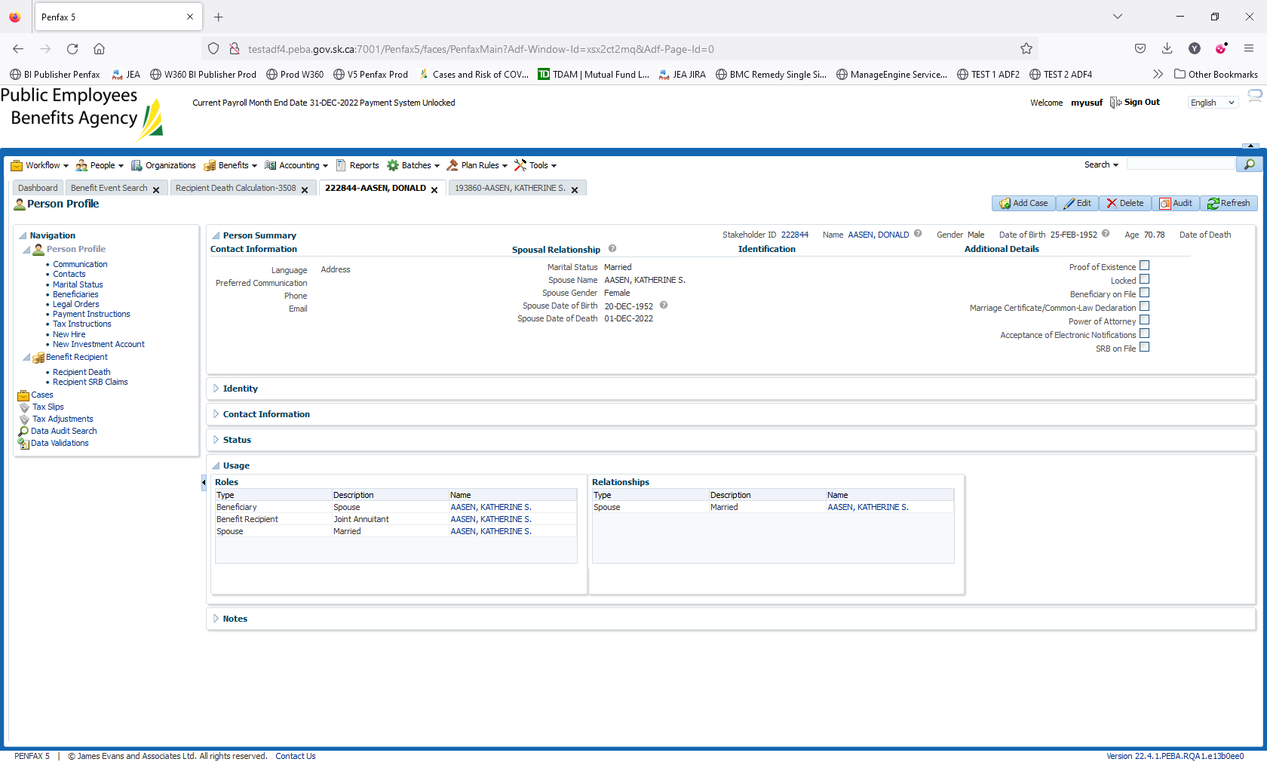

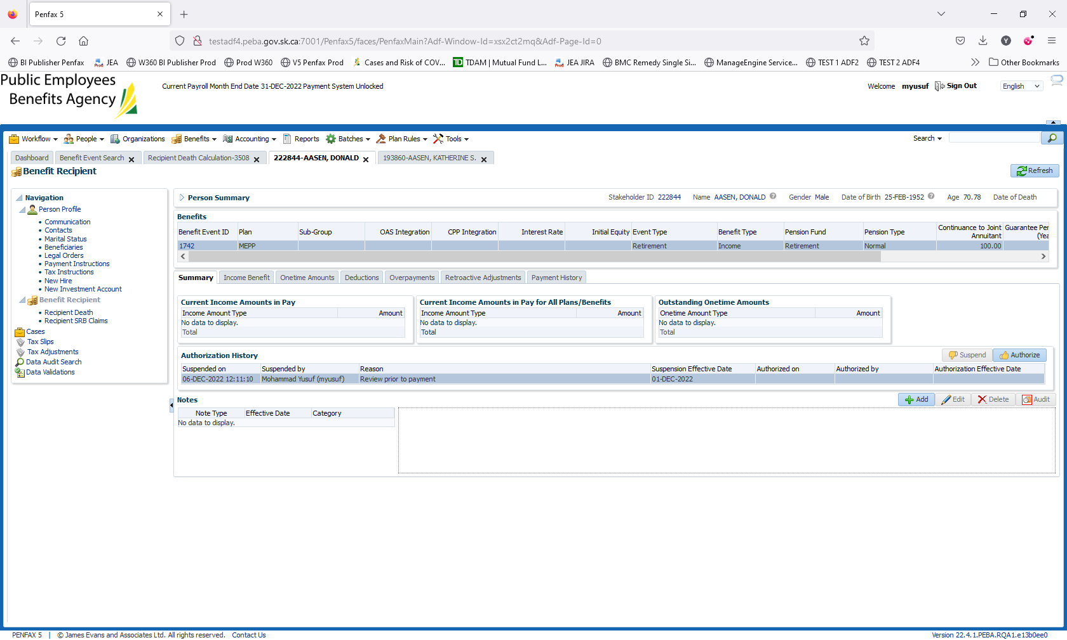

Click on Authorize

